APPENDIX A
PHOTOGRAPHS TAKEN DURING (LEAK) JIV AT 6” AZUZUZAMA MANIFOLD/TEBIDABA PIPELINE AT AZUZUAMA COMMUNITY, SOUTHERN IJAW L.G.A, BAYELSA STATE ON 13TH JULY, 2024.
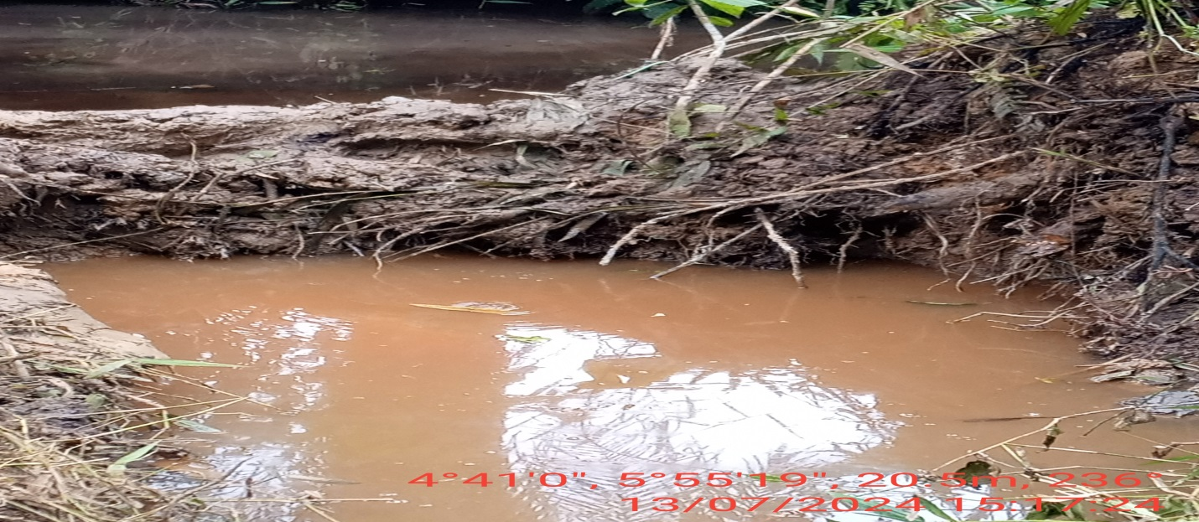
FIG. 1: THE INCIDENT POINT BEFORE EXCAVATION.
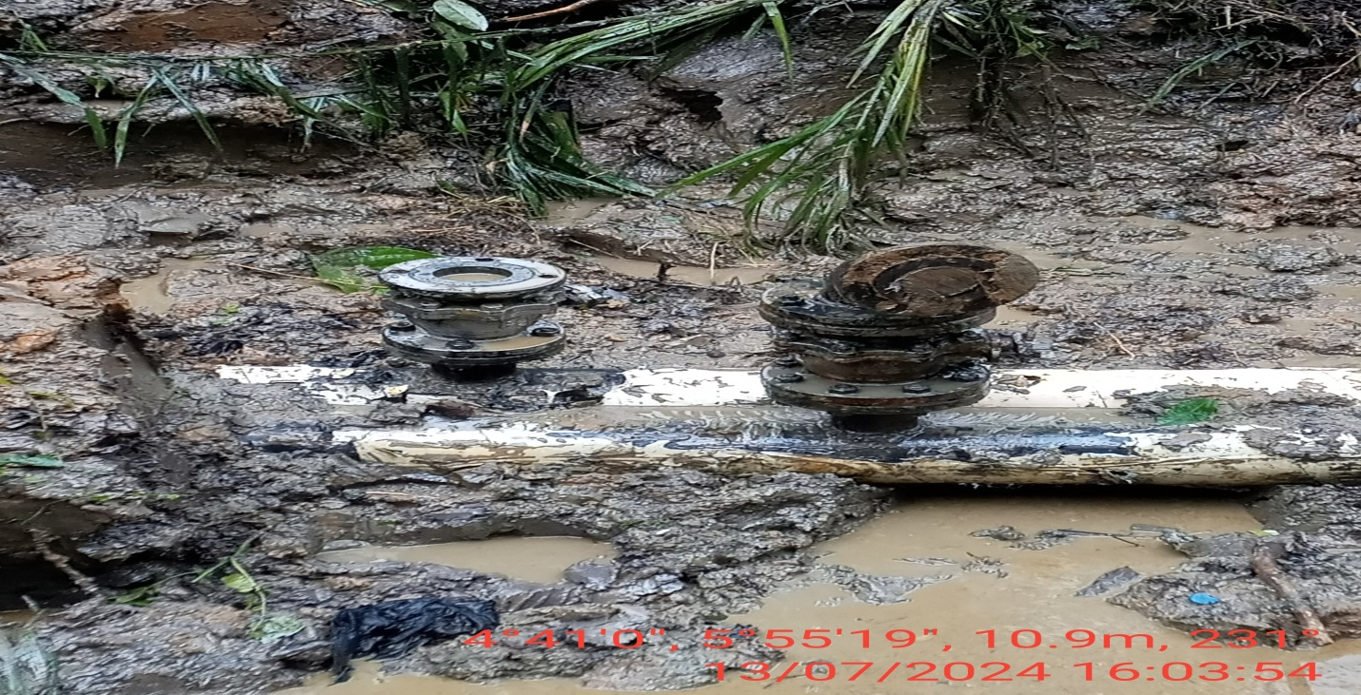
FIG. 2: 3” FLANGE INSTALLED BY VANDALS AT 12 O’ CLOCK POSITION OF THE PIPELINE FOR POSSIBLE THEFT ACTIVITY.

